Experiment 3
AIM: Develop Expense Tracking Module with Exception Handling.
Source: Program.cs
Code:
using System;
using System.Collections.Generic;
using System.Linq;
using System.Text;
using System.Threading.Tasks;

namespace Practical_3
{
class Expense
{
public int Expid;
public string Category;
public double Amount;
public string Payment_Method;
public DateTime Date;

public void addExpense()
{
Console.Write("Enter Expense ID:");
Expid = Convert.ToInt32(Console.ReadLine());

Console.Write("Enter Category:");
Category = Console.ReadLine();

Console.Write("Enter Amount:");
Amount = Convert.ToDouble(Console.ReadLine());

try
{
if (Amount < 0)
{
throw new ArgumentException("Expense cannot be negative.");
}
}
catch (ArgumentException ex)
{
Console.WriteLine(ex.Message);
Console.Write("Enter Amount:");
Amount = Convert.ToDouble(Console.ReadLine());
}

Console.Write("Enter Payment Method:");
Payment_Method = Console.ReadLine();

Console.Write("Enter Date (DD-MM-YYYY):");
Date = DateTime.Parse(Console.ReadLine());
}

public void displayExpense()
{
Console.WriteLine("Expense ID: " + Expid);
Console.WriteLine("Category: " + Category);
Console.WriteLine("Amount: " + Amount);
Console.WriteLine("Payment Method: " + Payment_Method);
Console.WriteLine("Date: " + Date.ToString("yyyy-MM-dd"));
}
}

internal class Program
{
static void Main(string[] args)
{
List<Expense> expenses = new List<Expense>();
int i = 0;
do
{
Console.WriteLine("==============================================");
Console.WriteLine(" Expense Management System");
Console.WriteLine("==============================================");
Console.WriteLine("1. Add Expense");
Console.WriteLine("2. Display Expenses");
Console.WriteLine("3. Total Expense Amount");
Console.WriteLine("4. Exit");
Console.Write("Enter your choice: ");

try
{
i = Convert.ToInt32(Console.ReadLine());
Console.WriteLine();
}
catch (Exception ex)
{
Console.WriteLine();
Console.WriteLine("----------------------------------------------");
Console.WriteLine("Enter Valid Integer Choice");
Console.WriteLine("----------------------------------------------");
Console.WriteLine();
}
Expense e = new Expense();
if (i == 1)
{
e.addExpense();
expenses.Add(e);
Console.WriteLine("----------------------------------------------");
Console.WriteLine("Expense Added Successfully");
Console.WriteLine("----------------------------------------------");
Console.WriteLine();
Console.WriteLine();

}
else if (i == 2)
{
foreach (Expense exp in expenses)
{
exp.displayExpense();

Console.WriteLine("----------------------------------------------");
Console.WriteLine();
}
}
else if (i == 3)
{
double sum = 0;
foreach (Expense exp in expenses)
{
sum += exp.Amount;

}
Console.WriteLine();
Console.WriteLine("----------------------------------------------");
Console.WriteLine("Total Expense Amount: " + sum);
Console.WriteLine("----------------------------------------------");
Console.WriteLine();

}
else if (i == 4)
{
Console.WriteLine();
Console.WriteLine("----------------------------------------------");
Console.WriteLine("Exiting the Program");
Console.WriteLine("----------------------------------------------");
Console.WriteLine();
}
} while (i < 4);
}
}
}

Output:
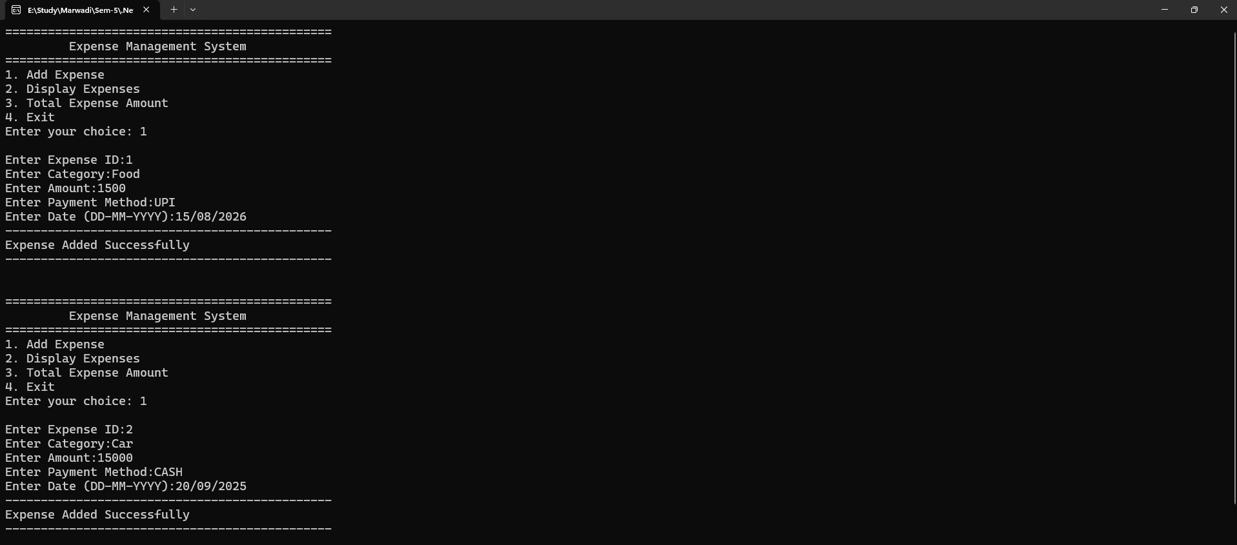

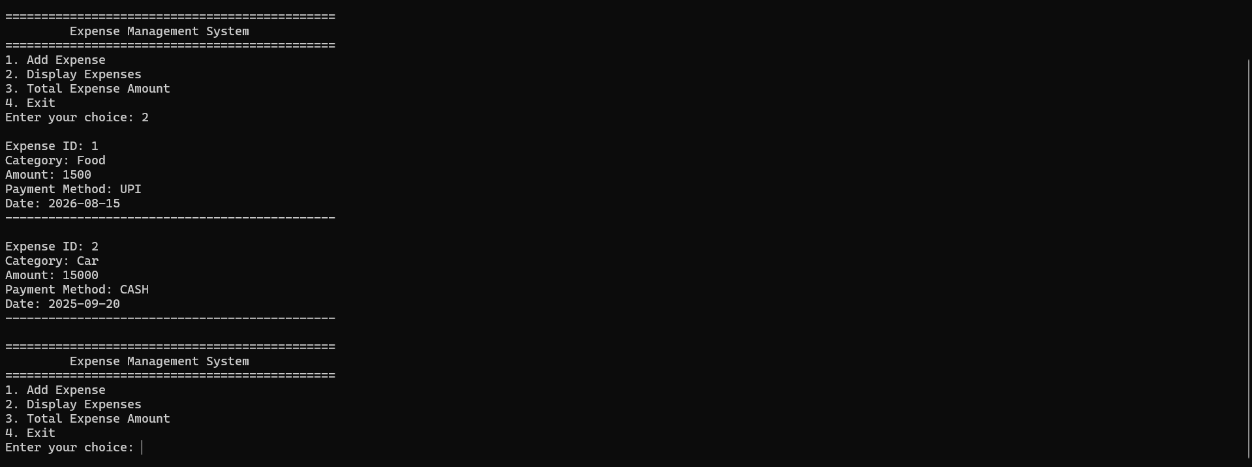

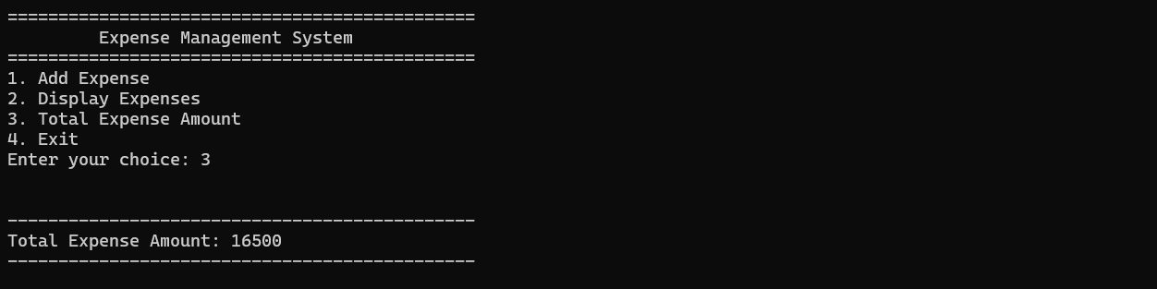

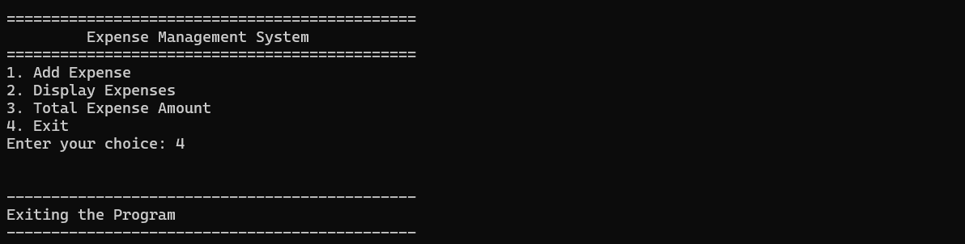

Github Url: https://github.com/jd-thakrar/Uni-DotNet-Work/tree/master/Practical-3

